2024 Annual Community Report

Introduction
St Francis Flexible School is part of Edmund Rice Education Australia (EREA), a network of schools that provide inclusive and flexible education for Young People who need extra support. Our school is guided by the EREA Touchstones: Liberating Education, which gives every Young Person the chance to learn in a way that works for them; Gospel Spirituality, which encourages kindness and respect; Inclusive Community, where everyone feels welcome and safe; and Justice & Solidarity, which teaches us to stand up for fairness and support each other. These values shape everything we do, helping Young People build confidence and a positive future.

Principal Message
Our school understands that everyone’s journey is different, and we’re here to help Young People grow, even if they’ve faced challenges in the past. Every day, we focus on building positive relationships, creating a safe and supportive environment, and encouraging Young People to work towards their own learning goals. Entering our second year as an Insight into Learning School, teachers and students are commenting on the benefits of our Daily Reviews and we are seeing the results through positive outcomes for our students. We enjoy working closely with our families to support the social, emotional, and learning needs of the Young People in our care.
A message from our Student Representative Council:
“As members of the SFFS Student Representative Council (SRC), We can honestly say that our meetings are a space where young people voices are genuinely heard. One of the biggest differences between the SRC at Flexi and mainstream schools is that here, staff actually listen. They’re upfront with us—if an idea isn’t going to work, they’ll tell us why, and that honesty helps us grow.
In our SRC, it’s the young people who decide which issues are important enough to take to senior leadership. The chair, who is the Director of Wellbeing (Practice), supports us but doesn’t control the agenda. We vote on issues and possible solutions, and if the majority agrees, it goes to the principal for a final decision.
What makes our SRC feel worthwhile is that staff take our feedback seriously. We’re not just ticking a box—our meetings lead to real change, and that makes us feel like our time and voices matter.
We’ve talked a lot about why student voice is important. Honestly, there’s no group more passionate about young people being involved in decision-making than our SRC. We take our roles seriously, we debate respectfully, and we hold each other accountable. If someone isn’t following the working agreement, it’s the SRC members who step in and ask them to return to class.
Every meeting, we elect a co-chair from the young people group to run the meeting alongside the chair. It’s a shared responsibility, and it shows how much trust and respect there is between staff and young people at Flexi."

Our Context
St Francis provides valued education to students from Year 7 to Year 12. As a Catholic school, we are part of Catholic Education Tasmania and the Edmund Rice Education Australia system of schools.
Located in West Moonah, St Francis Flexible School began its journey in Chigwell in February 2016 with a small group of students and staff. The school quickly grew, and by 2017, it had expanded significantly, prompting the renovation of a larger building. The Official Opening Ceremony was held in October 2017.
As enrolments continued to increase, it became evident that the Chigwell site required extensive repairs. In 2019, with government support, the school secured a long-term lease for the former Springfield Gardens Primary School. After significant renovations, we relocated to our new site in West Moonah in 2022. Our students now enjoy a strong sense of belonging and benefit from excellent facilities designed to support their learning and wellbeing.
In 2023, we officially changed our name to St Francis Flexible School to better reflect our mission and approach.
St Francis Flexible School is committed to providing a trauma-informed, inclusive, and supportive learning environment. We recognise that many of our students have experienced complex life circumstances that can impact their engagement with traditional education. Our approach is grounded in flexible, relationship-based, and student-centred practices that prioritise safety, trust, and empowerment.
We offer an alternative educational model tailored to meet the needs of disengaged young people. Through personalised learning plans, therapeutic support, and a strong focus on wellbeing, we aim to re-engage students in their education and help them build pathways to a positive future.
We are excited to be expanding our reach, with new schools opening in the North and North-West of Tasmania in the near future.

Students
During 2024, there were 162 students enrolled. The table below includes the breakdown of our students:
Year level/s | Total Students | Female | Male | Aboriginal and Torres Strait Islander
7 -10 | 97 | 43 | 54 | 28
11-12 | 49 | 25 | 24 | 24

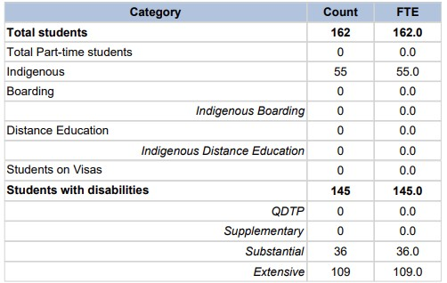

St Francis provides an excellent faith based educational experience for its students and those in need of a different approach to learning with particular focus on trauma-informed practices. The outstanding team of educators and staff at St Francis live and promote our Catholic ethos and the values of the School. St Francis employs a team of highly-skilled professionals who are dedicated to providing the best pastoral and learning support to enable each student to achieve their fullest potential.
Further information on our school can be found on our website Our School Story - St Francis Flexible School or contacting our office on 0427 249 286 during school hours.

Teacher Standards and Qualifications
All teachers at St Francis are registered to teach in accordance with the requirements of the Teachers Registration Board Tasmania.
We have 20 teachers working at St Francis. In 2024, we had 16 holding full registration.
Our teaching team is among the most experienced in Catholic education, with the majority of our educators having dedicated over 15 years to their practice. This depth of experience enriches our learning environment, ensuring that students benefit from seasoned expertise, deep pedagogical knowledge, and a strong commitment to faith-based education.
Provisionally registered teachers are supported through CET’s Early Careers Program and are given the opportunity and support to progress to full registration.
A breakdown of teachers and qualifications are tabled below:

Degree | No. of qualification held Teachers
Postgraduate Certification | 6
Diploma | 3
Bachelor | 28
Masters | 6

Professional Learning
Professional learning is a key focus at St Francis. All staff attended CET’s System Insight Days at the beginning of each term - further information on our school specific Insight into Learning program is available by contacting our Director of Curriculum, Sarah Adams.
Other professional learning undertaken at St Francis this year has included:
Professional Learning activity | Number of staff participating
Trauma Aware Practise | 51
Youth Mental First Aid Training | 49

Workforce Composition
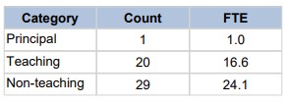

Full time teaching staff | 12
Part time teaching staff | 9
Full-time equivalent teaching staff | 5.6
Full time non-teaching staff | 17
Part time non-teaching staff | 8
Full-time equivalent non-teaching staff | 4.6
Number of Aboriginal and Torres Strait Islander Staff | 6

School Attendance

At St Francis, we are committed to supporting every young person’s right to education. In line with legislative requirements, schools must be informed of the reasons behind a young person’s absences. We kindly ask that young people or their families or carers notify us if they will be absent from school. You can let us know ahead of time if there is a planned absence, or on the day if not planned.
Notification of Absence can be done easily via:
- A phone call, voicemail, text message or email to the class partnership
- Or by contacting School Administration on 0427 249 286
As a trauma-informed school, St Francis has processes in place to support regular attendance. When a student is absent, we follow up each day they are away. For students under 18, we also contact their parent or guardian. If we are unable to reach them directly, we leave a voicemail and send a text message explaining the reason for our call.
Signing Out
Young people are only able to sign out if they have been given permission to do so by a guardian. Young people are only able to sign out during recess time and lunch time. If young people sign out outside of these times, or do not return during recess or lunch time, they will not be able to participate in school for the remainder of the day.
Late Arrivals and Early Departures
If a young person arrives to school late, they can participate in class but must sign in at the administration office. If a young person chooses to leave site early, they must sign out. If a young person is late or leaves early, guardian or carer will be contacted every time.

For whole school student attendance rates, please refer to the school’s data on My School Unauthorised Absences at St Francis Flexible School. The Principal, Deputy Principal, Class Partnerships and permitted Administration staff are authorized to follow up unauthorized absences at St Francis. Where the school has not been notified of a student absence by 10.30am, parents/guardians/carers/independent young people will be notified by text message requesting they follow up with the school. Where an absence remains unexplained, the student will be marked as an unauthorized absence. The process for following up unauthorised absences with parents/guardians/independent students is outlined in the CET Attendance Policy.
These steps help us ensure that every young person is safe, supported, and engaged in their learning journey.
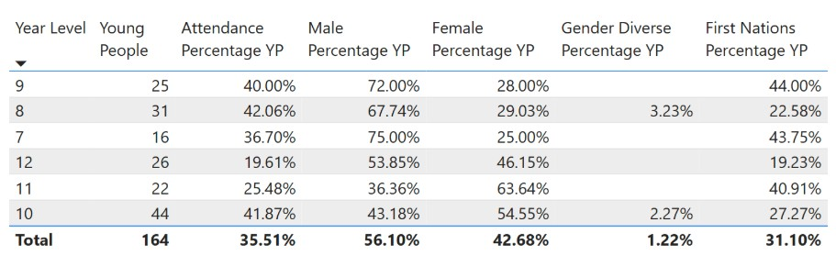
Parent, student and teacher satisfaction

St Francis is committed to listening to the views and expectations of our community and is utilising the School Effectiveness Survey’s to obtain feedback on a wide range of related educational and wellbeing topics. The feedback from these surveys supports St Francis with both its annual and strategic planning and its commitment to continually improve the educational and wellbeing outcomes for our students.
In 2025, 5 parents, 28 students and 60 staff participated in surveys and provided views to improve the spiritual growth, wellbeing and learning of every student.
Students:
A selection of the student’s top-level findings are detailed below:
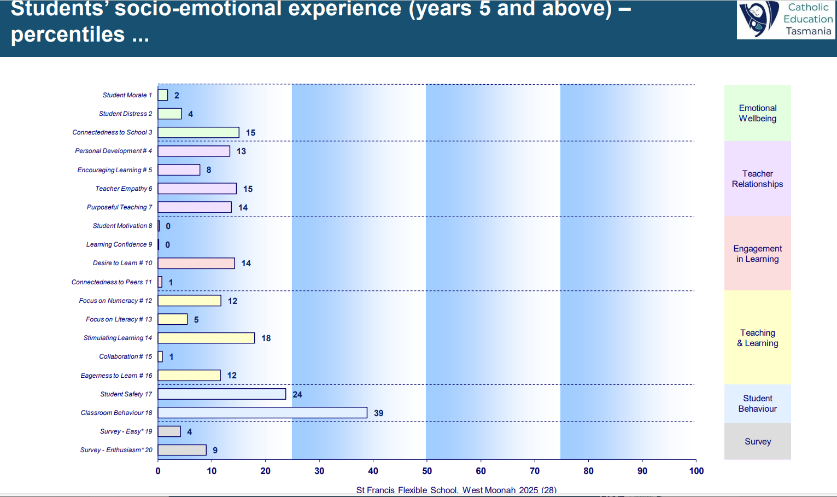
Parents:
A selection of the parents top level findings are detailed below:
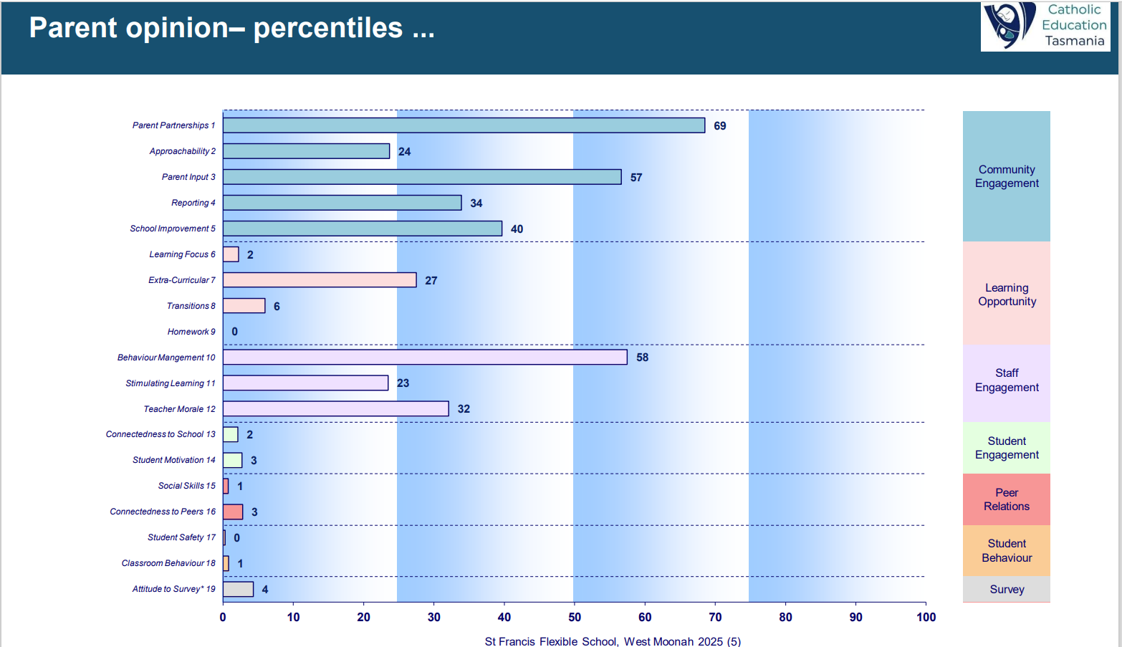
Teachers:
A selection of the teacher’s top-level findings are detailed below:

Empowerment

 | Strongly Disagree |  |  |  | Strongly Agree
 | 1 | 2 | 3 | 4 | 5 | Average
There are forums in this school where I can express my views and opinions. | 2 | 1 | 4 | 12 | 11 | 4.0
I am happy with the decision-making processes that are used in this school. | 0 | 3 | 6 | 9 | 12 | 4.0
Staff in this school are frequently asked to participate in the decisions that affect the way they do their work. | 4 | 0 | 8 | 10 | 8 | 3.6
There is opportunity for staff to participate in decision-making in this school. | 1 | 3 | 6 | 9 | 11 | 3.9

Ownership

 | Strongly Disagree |  |  |  | Strongly Agree
 | 1 | 2 | 3 | 4 | 5 | Average
The staff are committed to the school’s goals and values. | 0 | 0 | 3 | 13 | 14 | 4.4
The goals of this school are not easily understood. | 10 | 12 | 4 | 3 | 1 | 2.1
This school has a clearly stated set of objectives and goals. | 0 | 2 | 4 | 13 | 11 | 4.1
My personal goals are in agreement with the goals of this school. | 0 | 1 | 5 | 12 | 12 | 4.2
There is agreement about the teaching philosophy of this  school. | 1 | 2 | 7 | 12 | 8 | 3.8

Teamwork
 | Strongly Disagree |  |  |  | Strongly Agree
 | 1 | 2 | 3 | 4 | 5 | Average
There is good teamwork in this school. | 1 | 2 | 2 | 13 | 12 | 4.1
There is good communication between groups in this school. | 2 | 5 | 6 | 8 | 9 | 3.6
Staff in this school can rely on their colleagues for  support and assistance when needed. | 2 | 0 | 5 | 6 | 17 | 4.2
Staff frequently discuss and share teaching methods and strategies with each other. | 0 | 4 | 6 | 12 | 8 | 3.8
There is good communication among staff in this school. | 3 | 1 | 4 | 12 | 10 | 3.8
I receive support from my colleagues. | 1 | 1 | 2 | 12 | 14 | 4.2

Finance
For Financial Information for St Francis Flexible School please refer to the school’s data on My School

Secondary Education
We connect each young person’s learning goals (developed in Collaborative Goal Setting meetings) to elements of the Australian Curriculum.
We work with the young people’s interest while focusing on the general capabilities of literacy, numeracy, as well as personal and social capabilities.
We offer programs to improve students’ skills in reading, writing, and mathematics as well as digital literacy:
- MacqLit
- The Writing Revolution
- Insight; High Impact Teaching in Literacy and Numeracy

Through these programs and more, students get the help they need to build strong Literacy and Numeracy skills and gain access to and familiarity with digital technology.
Senior students can do VET courses and earn micro-credentials. They can also access programs such as Build Up Tasmania, pre-apprenticeship courses, and Work Experience. Young people have a strong voice in their learning and getting the help they need to live a good life.

